1. Access modifiers:

>Public

>Protected

>Default

>Private

Public:

Public access modifier is specified using public keyword, declared at class, method and variable are accessible from everywhere in the program.

It is a global level access and it can be accessed using object and Extends keyword.

Protected:

Protected access modifier is specified using protected keyword, declared at class, method and variable.

Inside the package we can call using object and extends keyword.

Outside the package we can call using extends keyword.

Default:

Default access modifier is when no access modifier is specified for class, method and variable

Default access modifiers are accessible inside the package only.

We call using creating object and extends keyword.

Private:

Private access modifier is specified using private keyword, declared at class, method and variable.

It is class level access only.

2)Exception is like an error, the program will terminate that line itself.

These are the errors that occur at compile time and run time.

**It can be recovered by using the try-catch block and throws keyword.**

There are two types of error. Checked and unchecked exceptions

Arithmetic exception, nullpointer exception, Arrayindexoutofbound exception, IoException, SQL Exception, Filenotfound Exception.

Error are problems that mainly occur due to lack of system resources.

**It cannot be caught or handled.**

These are always unchecked

Outofmemory error, Network error, JVM Crack.

3)Checked exceptions are called compile time exceptions.

Example:IO Exception, ClassNotFound Exception, SQL Exception

Unchecked exceptions are called runtime exceptions.

Example: Airthmetic Exception, ArrayIndexOutOfBound Exception, NullPointer Exception

4) Airthmetic Exception

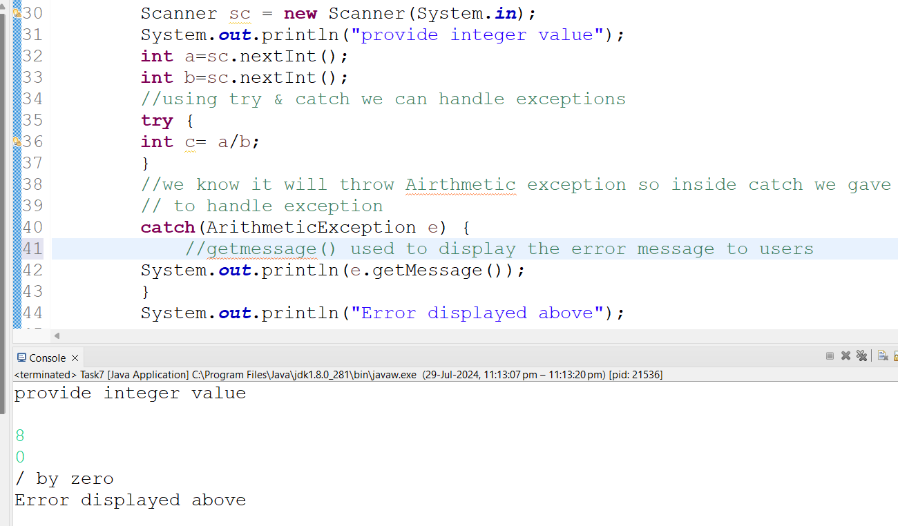

5)ArrayIndexOutofBound Exception

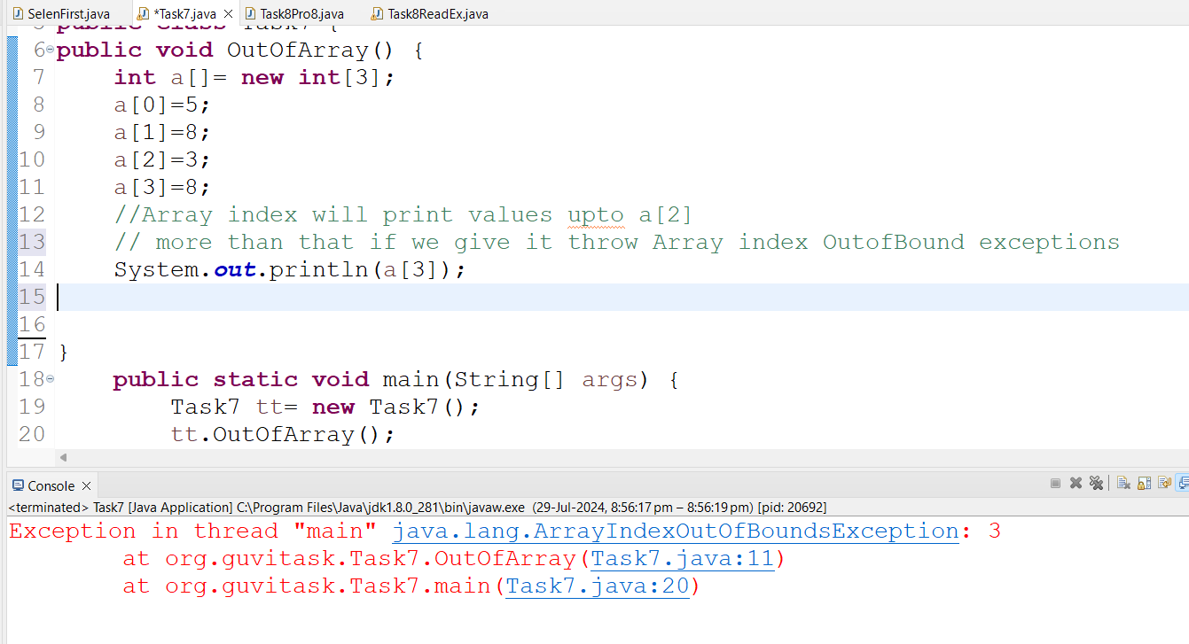

StringIndexoutofBound exceptions:

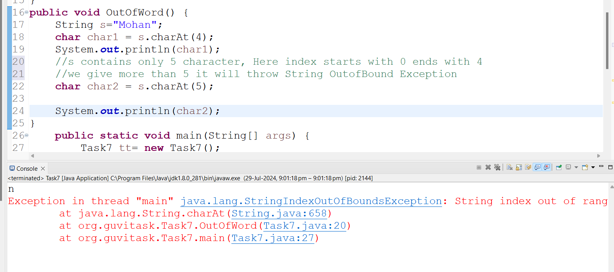

6) Wrong Password using exception handling:

Creating exception class and by extending Exception we can make use of all the properties in Exception class

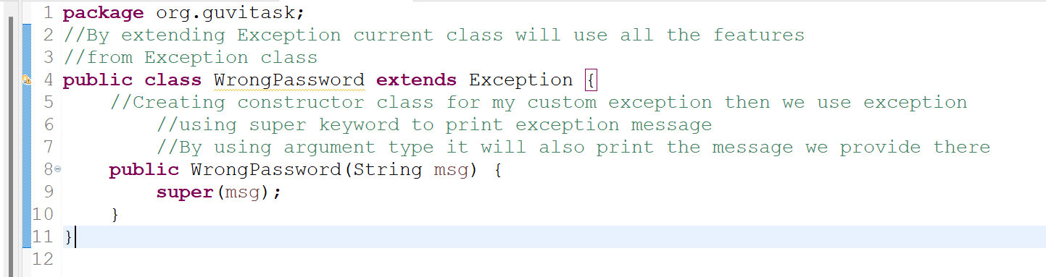

7) Invalid Age Exception:

There is no “invalidageexception” class, So we need to create new class and use that class whenever we required.

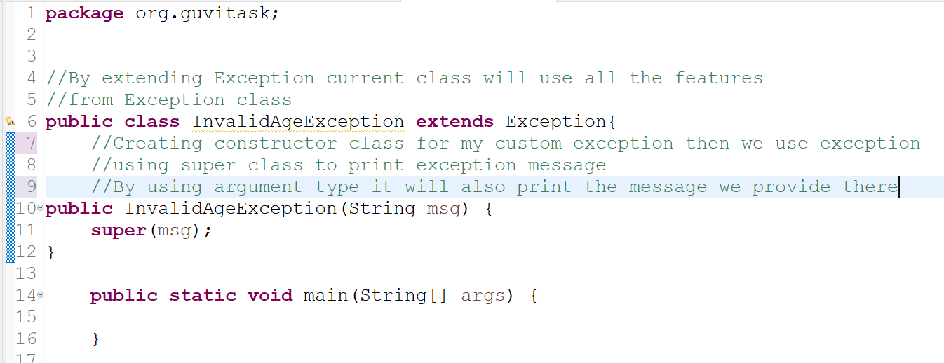

If Age is below 18 it should throw InvalidAgeException error

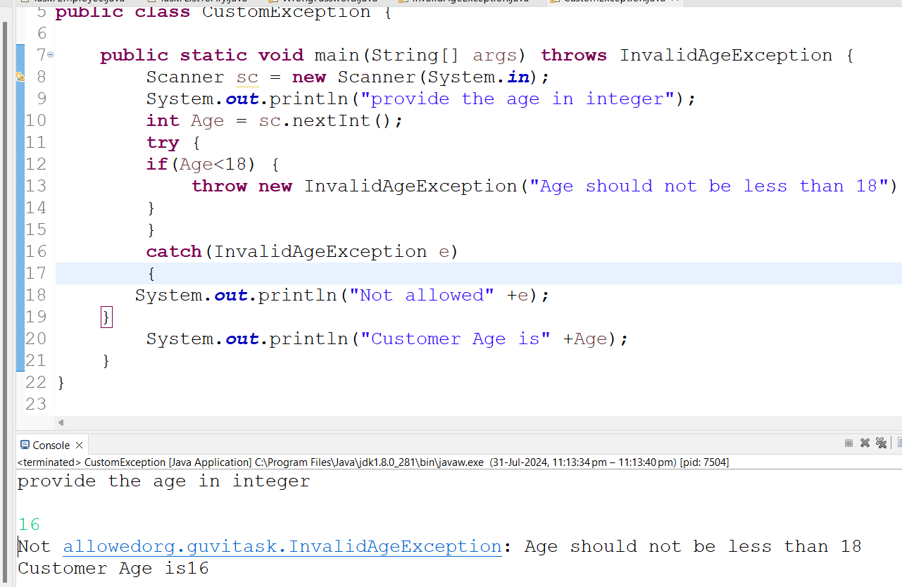

If age is not less than 18 it should not throw InvalidAgeException

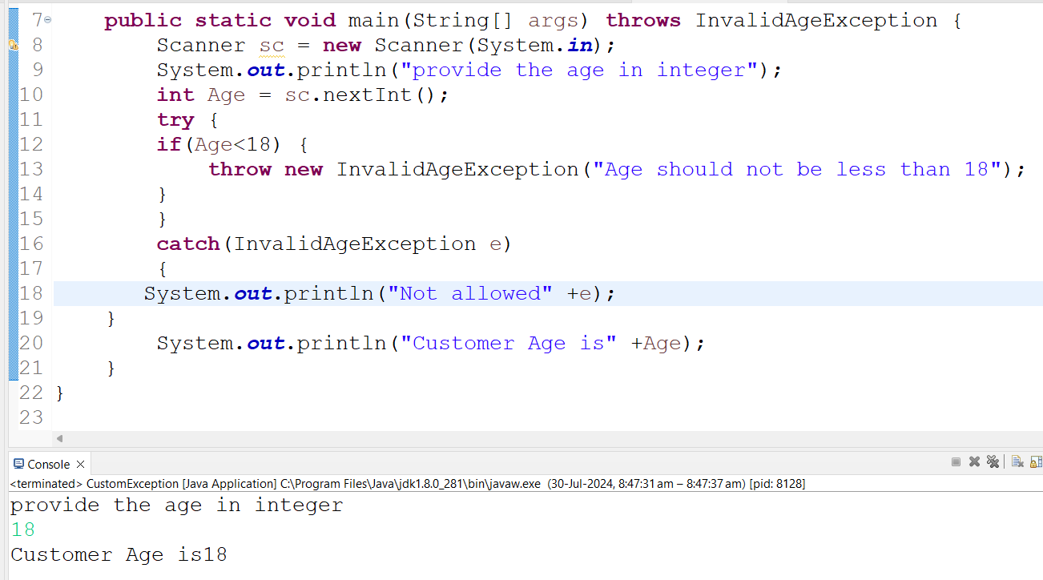

8) FileNotFound Exception

